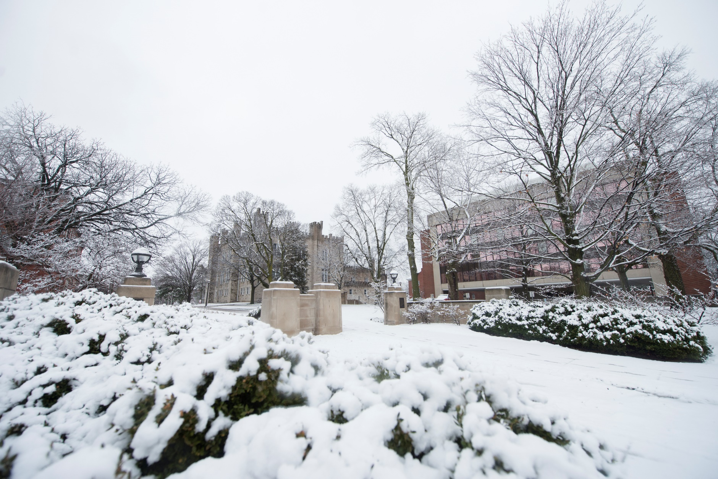
November 2018

Off-Campus Living
Emergency Planning Handbook
A guide to preparing for and responding to emergencies
EmergencyManagement.IllinoisState.edu

This page intentionally left blank

Address:
[Building/Complex Name]
[Address]
[Apartment number if applicable]

Resident(s):  A contact list can be found in section 7.2  Rendezvous Areas:  Primary: [Identify location]  Secondary: [Identify location]  Shelter Locations:  Primary: [Identify location]  Secondary: [Identify location] | Emergency Contacts:  A full contact list can be found in section 7.2  [List names and office/cell phone numbers of persons that need to be contacted in the case of an emergency such as a landlord and utility providers]
AED Location(s):
[Identify location(s)]

Fire Extinguisher Location(s):
[Identify location(s)]

For additional information regarding creating emergency action plans, visit: EmergencyManagement.IllinoisState.edu
For additional information regarding overall campus safety and security, visit: Security.IllinoisState.edu

Table of Contents
1: Introduction 5
1.1 Purpose 5
1.2 Responsibilities 5
2: Quick References 6
2.1 Building Map/Apartment Floor Plans 6
3: Communications 7
3.1 Reporting Emergencies 7
3.2 Campus Emergency Notification 7
3.3 Intercommunication 8
4: Emergency Actions 9
4.1 Evacuation 9
5: Preparedness 10
5.1 General Home Safety 10
5.2 Kitchen Safety 10
6: Types of Emergencies 11
6.1 Medical Emergencies 11
6.2 Tornado Warnings 11
6.3 Explosion 11
6.4 Earthquake 12
6.5 Fires 12
6.6 Other Emergencies 14
7: Attachments/Appendices 15
7.1 Attachment 1: Emergency Items and Equipment 15
7.2 Attachment 2: Contact Lists 16

1: Introduction
  - Purpose
This Handbook is designed to provide you, your roommates and guests with guidance on how to prepare for and respond to a range of emergencies. You are welcome and encouraged to modify this handbook to address other topics or to remove ones that do not pertain to your living arrangement.
  - Responsibilities
All students share the responsibility of emergency preparedness. You are encouraged to work with your housemates/apartment-mates/roommates to familiarize yourselves with the actions outlined in this handbook. In addition, you should:
- Sign up for ISU Emergency Alert;
- Have an up-to-date emergency kit for your home and car;
- Maintain a current list of emergency contact information;
- Procure and maintain necessary emergency supplies, equipment and items;

2: Quick References

2.1 Building Map/Apartment Floor Plans

[Insert Building Map/Apartment Floor Plans Here with designated Rendezvous Areas and Shelter Locations]

3: Communications

3.1 Reporting Emergencies
Report emergencies by calling 911. All 911 calls are answered by METCOM, the county’s emergency dispatch center; therefore, you should indicate to the dispatcher your exact location. This will help the dispatcher determine which police/fire department to dispatch.
When reporting an emergency situation, provide the dispatcher with the following information:
- Your name
- The location of the emergency
- The nature of the emergency - a brief description
- Any additional information they request
Note: Do not hang up. Stay on the phone until the dispatcher advises it is okay to end the call.

3.2 Campus Emergency Notification
An ISU Emergency Alert will be used by the University to notify members of the campus community of an emergency which threatens life or safety on campus.
If you receive an ISU Emergency Alert:
- Immediately respond in accordance with directions provided via the alert, and/or use best judgment on how to respond based on your specific set of circumstances and location.
- Communicate by word-of-mouth to others who may have not yet received the alert.
- Updates will be posted to IllinoisState.edu, so check back in regularly.
- Remain calm and make wise decisions relative to your personal safety.
If you have provided your text-enabled mobile phone number in Campus Solutions, you will automatically receive ISU Emergency Alerts.
All faculty, staff and students are encouraged to register for ISU Emergency Alerts by visiting IllinoisState.edu/EmergencyAlert.

3.3 Intercommunication
Your housemates/apartment-mates/roommates may not be together when an emergency takes place, so it is important plan in advance.
Plan to stay or go: depending on your circumstances and the nature of the emergency, the first important decision is whether you stay where you are or evacuate. You should plan for both possibilities. For example, you might evacuate during a fire or structural collapse and you may seek shelter for a tornado or outdoor hazardous materials release.
You should make sure you have contact information for your housemates/apartment-mates/roommates programed into your phone. A full contact list can be found in section 7.2.
You should know your way out of your room, apartment, and building in an emergency. Two exits should be identified for each room; keep in mind that the second exit may be a window. You should identify rendezvous locations as well as locations for Tornado Shelter Areas that are in basement or first floor interior rooms with no large windows.
Utilize this space to describe the communication methods that you will use in order to communicate any emergency between roommates/housemates.
Things to include
- Identify an emergency out of town contact.
- List and distribute important contact information
- Verify that all your friends/roommates know the phone numbers in the plan.
- Exits for all rooms, apartments, and buildings in an emergency
- Any housemates/apartment-mates/roommates that require medications at all times, and/or have a disability that effects them from normal evacuation procedures
- Have a rendezvous point to meet either near the apartment or far-removed depending on whether you plan to stay or go (Both of these locations should be near first responders so emergency information can be shared)
- Closest area to seek refuge from a tornado

4: Emergency Actions

4.1 Evacuation
When an evacuation has been ordered or is warranted, all building occupants are to immediately evacuate.
Evacuate by following the nearest Exit signs:
- If nearby, take your cell phone with you.
- DO NOT use elevators if evacuating due to a fire or fire alarm.
- Evacuate to your designated Rendezvous point. Assist anyone needing help while not compromising your own safety.
- Advise Emergency Personnel if you are aware of any person taking refuge in an Area of Rescue Assistance.
- After reporting to the designated Rendezvous point, be prepared to begin the accountability process.
- Advise first responders if you believe someone is missing or trapped inside and/or is in need of assistance.
- Stay out of the way of emergency personnel and equipment.
- Do not re-enter the building until you are approved to do so by the Police or Fire Department.

If trapped in the building:
If trapped due to smoke/fire:
- Call 911 and let dispatchers know your situation and location.
- If possible, move to a window and signal for help.
If trapped due to intruder:
- Follow Run, Hide, Fight procedures (see Campus Safety & Security website for information on this topic)

Rendezvous
The Rendezvous point(s) are located:
[Insert locations here].

4.1.1 Accountability
After evacuating, you should immediately account for everyone to ensure the whereabouts and wellbeing of each individual within your household/apartment. This is important so you can share the status of any missing people with first responders, who will conduct searches.

5: Preparedness
Preparedness is the responsibility of every person within the community and starts in your residence. Emergencies typically occur without warning, so any one of us could be in a position to act in a moment’s notice.
Every member of the ISU community shares the responsibility of emergency preparedness. Signing up for ISU Emergency Alert is the best way to be notified of a campus emergency. Visit IllinoisState.edu/EmergencyAlert to learn how to sign up.
Visit the Emergency Management website (EmergencyManagement.IllinoisState.edu) to find guidelines for building an emergency kit for the home and car. Every home should have a kit that can supply all occupants with basic needs for up to 72 hours.
[Insert kit location(s) here].

5.1 General Home Safety
Living areas should have both smoke detectors and carbon monoxide (CO) detectors or a combination detector. Batteries in all detectors should be changed twice a year, generally coordinated with changing clocks for daylight savings time.
You should never hang anything from sprinkler heads and never cover up any fire detection or suppression systems. You are encouraged to purchase an ABC fire extinguisher for your apartment. Extinguishers can be found at any home improvement store. See Section 6.5.1 Extinguishers on proper usage.
Theft is a common crime in University communities. You should keep bikes locked at all times when not using them, even if you just step a way for a minute. You are also encouraged to keep a list of your valuables (bike, electronics, etc.) with photos, serial numbers and model numbers. This list should be kept somewhere safe and a copy should be kept with a parent/guardian. This will make it easier for police to track down stolen valuables.

5.2 Kitchen Safety
You should understand kitchen safety and proper usage of stoves, ovens, and microwaves. You should never leave the apartment when any kitchen appliance is hot. Never put water on a fire in the kitchen; instead, use a fire extinguisher or cover it up.

6: Types of Emergencies

6.1 Medical Emergencies
- Call 911.
- Provide medical assistance with-in your level of knowledge/training.
- Do not attempt to move a person with a suspected head or neck injury unless imminent danger is present.
- Remain with the individual until emergency medical personnel arrive. Be prepared to share pertinent information with First Responders.
- Automated External Defibrillators (AEDs) should be used in the event of a sudden cardiac arrest emergency. Cardio Pulmonary Resuscitation (CPR) can be performed by anyone trained in CPR.
[Identify AED location(s) here, if applicable].

6.2 Tornado Warnings
Tornado Warnings will be issued when a funnel cloud or tornado has been spotted or RADAR has indicated a tornado threatening the area. In addition to the National Weather Service warning, the Bloomington/Normal Outdoor Warning Sirens will also be activated when a Tornado or funnel cloud has been spotted. In either case, you should to take cover immediately. In the event of a tornado warning, you should:

- Collect Emergency Equipment
Keep a cell phone with you in order to receive additional emergency information or to monitor the National Weather Service for updates. Keep a flashlight and a portable battery operated radio in a common area, if possible.

- Take shelter
Immediately move to inner hallways, stairwells, underground tunnels, rest rooms, or other areas on the lowest level of the building which are directly supported and relatively free from exterior windows and glass. If you are outside during a tornado warning and do not have time to move inside for shelter, move to a ditch or other low spot below grade level where you can lie (flying debris causes most deaths and injuries during a tornado).
[Note designated areas here]

- Avoid Dangerous Areas
Always avoid the upper floors of a building and areas such as elevators, lobbies, gyms, atriums, auditoriums, any area with windows, or dining centers.

6.3 Explosion
- Immediately take cover.
- Remain inside the building until it is considered safe to exit.
- Follow your evacuation procedure once determined it is safe to evacuate and proceed to your rendezvous point.

6.4 Earthquake
- Remain calm.
- Seek refuge under a bed, table, or stable item. Face away from windows and glass.
- Cover the back of your neck and head.
- If outside, get to the nearest open space. Stay away from buildings, overhangs, utility poles, trees, and power lines.

After the earthquake:
- Call 911 only to report any injuries or immediate health hazards.
- If in a building, exit the building (being careful to not take any route that appears to be unstable/unsafe), and proceed to your rendezvous point.
- Advise the first responders of anyone who may be trapped in the building.

6.5 Fires
If you see smoke or fire, immediately evacuate by following the nearest Exit signs:
- If the alarm is not already sounding, pull the nearest fire alarm pull station to alert other building occupants of the fire.
- If nearby, take your cell phone with you.
- Be alert for smoke as you exit the building.
- Before exiting through a door, check the door and handle. If the door or handle are hot to the touch or smoke is present, do not open the door.
- DO NOT use elevators.
- Follow evacuation procedures
  - Evacuate to proceed to your rendezvous point.
  - Assist anyone needing help while not compromising your own safety.
- If you have knowledge of the specific location of the fire, its source, or other pertinent information call 911 once safely out of the building.

If trapped in the building:
- Try to get as far away from the fire/smoke as you can and take refuge in a room, preferably one with an outside wall and window.
- Attempt to seal the base of your door (wet towel or cloth if possible) to prevent smoke from entering.
- Call 911 and let them know your situation and location.
- If possible, move to a window and signal for help.

6.5.1 Fire Extinguishers
Portable fire extinguishers should be readily available in your apartment and may be used provided the following conditions are met:
- The fire alarm pull station has been activated and the alarm is sounding.
- The observer has been trained on the use of the portable fire extinguisher and feels confident that he/she can safely extinguish the fire.
  - You are not required to fight the fire. If you are uncomfortable or unfamiliar with usage of a fire extinguisher you are not required to do so.
- If nearby, take your cell phone with you.
- Before fighting a fire, ensure that the fire does not block your escape path—in other words, position yourself with your back to your escape route when you fight the fire.
- Ideally, there should also be a second person with an extinguisher to act as a backup, and as a lookout.
- To attack a small fire, initially position yourself with the extinguisher 6-8 feet away from the fire, and then work your way closer if necessary, but only if it is safe to do so. Starting too close may scatter the burning contents before the extinguishing agent does its job.
- To use a fire extinguisher, it is helpful to remember the acronym PASS. PASS means:

- Once the fire has been extinguished, ensure that someone has called 911 and the fire department is en-route, so they can evaluate whether further response is needed.
- Ensure that someone keeps an eye on the extinguished fire until the fire department arrives, in the event the fire rekindles.
Fire Extinguisher(s) in are located: [insert location(s) here]

6.6 Other Emergencies
[Describe in this section any other emergency procedures that should be written down which are pertinent to your apartment/household.]

7: Attachments/Appendices

7.1 Attachment 1: Emergency Items and Equipment
Housemates/apartment-mates/roommates are encouraged to build a kit with items to sustain themselves for 72 hours in case of emergencies. List the location of this kit and other emergency supplies and items your apartment maintains or has access to:

Emergency Supply or Item | Location(s)
Copy of this Plan
Contact List
Emergency Kit
First Aid Kit
Water
Battery operated radio
Flashlights (w/ extra batteries)
Automated External Defibrillator (AED)
Fire Extinguisher

7.2 Attachment 2: Contact Lists
Housemates/apartment-mates/roommates should compile a list of their phone numbers along with an emergency contact for everyone. This list should be easily accessible during an emergency and contacts should be programmed in each housemate/apartment-mate/roommate’s phone
Housemate/Apartment-mate/Roommate Name | Number | Emergency Contact | Number | Relationship
Housemates/apartment-mates/roommates should also compile a list of important contacts for communication during an incident. Housemates/apartment-mates/roommates can list a secondary emergency contact number/family member on this list. This list should be easily accessible during an emergency and contacts should be programmed in each housemate/apartment-mate/roommate’s phone.
Name | Phone | Relationship
 |  | Landlord
 |  | Maintenance
ISU Police Department | (309) 438-8631 | Police
ISU Dean of Students Office | (309) 438-2008
ISU Student Health Services | (309) 438-8655 | Health/Medical
Normal Police Department | (309) 454-9535 | Police
Normal Fire Department | (309) 454-9689 | Fire
Advocate Bromenn Hospital | (309) 454-1400 | Health/Medical
St. Joseph Medical Center | (309) 662-3311 | Health/Medical

